# CURRICULUM VITAE

OF

## MD. FIROZ MAHMUD NUR

| **Contact address** |
| --- |

C/O - Md. Shahidul Islam

Village: Guabari Post Office: Pirgachha(5450)

Police Station: Pirgachha District: Rangpur

Mobile: +880 1724-549726

Email: [md.shahidul.islam.9726@gmail.com](mailto:md.shahidul.islam.9726@gmail.com)

| **Career Objective** |
| --- |

Looking for a Challenging Job A competitive environment where my knowledge can be leveraged to bring the maximum benefit to the organization as well as to me.

| **Educational Qualifications** |
| --- |

| **Higher Secondary School Certificate (H.S.C)** |
| --- |

Institute : Police Lines School And College, Rangpur

Board : Dinajpur

Group : Science

Result : GPA 5.00 (out of 5.00)

Passing Year : 2021

| **Secondary School Certificate (S.S.C)** |
| --- |

Institute : Pirgachha J. N. Govt. Model High School

Board : Dinajpur

Group : Science

Result : GPA 5.00 (out of 5.00)

Passing Year : 2019

| **Training** |
| --- |

| **Computer Office Application** |
| --- |

Duration : 6 Months (360 Hours)

Institute : Bangladesh Technical Education Board, Dhaka

Result : A+

Passing Year : 2019

| **Computer Skill** |
| --- |

MS Office, Google Drive, Spreadsheets, Email, Social Media, Graphics

| **Language Skills** |
| --- |

| Language | Reading | Writing | Speaking |
| --- | --- | --- | --- |
| English | High | High | High |
| Bengali | High | High | High |
| Hindi | - | - | Medium |

| **Interest and Hobby** |
| --- |

Online Browsing, Learning New Things, Photography and Traveling.

| **Special Skills** |
| --- |

Motorcycle Driving, Communication, Computer literacy

| **Personal Information** |
| --- |

Name : Md. Firoz Mahmud Nur

Father’s Name : Md. Shahidul Islam

Mother’s Name : Mst. Afroza Begum

Present Address : Village: Guabari Post Office: Pirgachha(5450)

Police Station: Pirgachha District: Rangpur

Permanent Address : Village: Guabari Post Office: Pirgachha(5450)

Police Station: Pirgachha District: Rangpur

Date of Birth : 27th September, 2003

Sex : Male

Religion : Islam

Marital Status : Unmarried

Height : 5’-5”

Weight : 50kg

Blood Group : O+

Nationality : Bangladeshi

National ID No. : 376 420 9759

Passport : Yes

Mobile Number : +880 1797-626050

Email ; [firoznur5@gmail.com](mailto:firoznur5@gmail.com)

| **Declare** |
| --- |

I certify that the statements made by me on the CV are true, complete and correct.

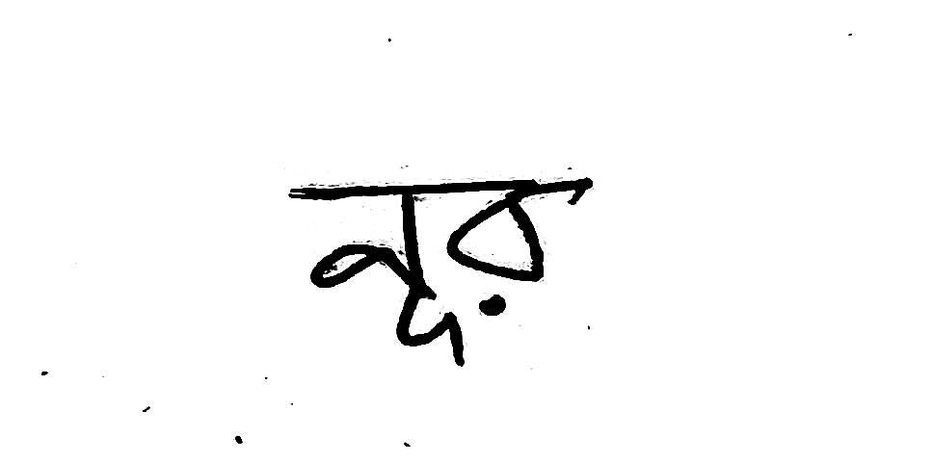Signature

........................

(Md. Firoz Mahmud Nur)